Tomorrow, May 26th, is our field trip to the New York Aquarium. The bus will be leaving promptly at 8:30. Please make sure all students arrive on time to school.
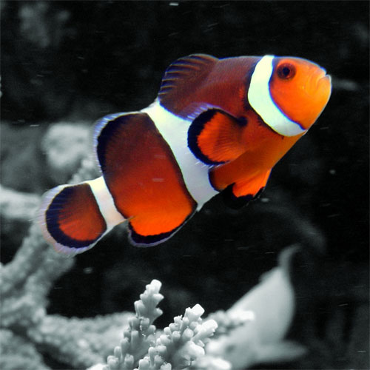
- Lunches must be in a disposable bag (we suggest double bagging in plastic grocery store bags), clearly labeled with your name, school, and teacher. No glass bottles are permitted. Students will be required to carry their own lunches.
- All students must wear comfortable shoes for walking and their Green Haledon T-shirt that was provided. Shorts are allowed; however, they must meet HPS dress code requirements and be appropriate. Remember we are representing Haledon on this trip.
- No toys or electronics will be allowed on the bus.
- Cameras are allowed; however, the child is responsible for carrying it. (Disposable cameras are best. The teacher is not responsible for lost or damaged cameras).

